**ARRAY2D – REVIEW**

**REVIEW OF EXERCICE 1**

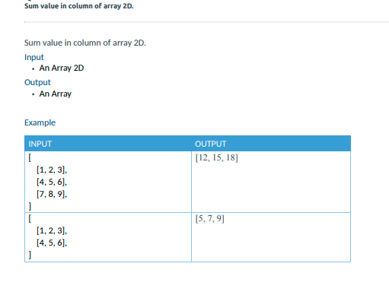

Q1 - Does this code is correct for this problem? Why? Where is the bug ?

array=eval(input())

result=[]

sizeColumns = len(array)

for i in range(sizeColumns):

    sum=0

    row = array[i]

Bug

    for j in range(row):



        sum+=row[j]

    result.append(sum)

print(result)

Answer:

This code is incorrect because the second for loop we need len(row).

Q2 – Now look at this code:

sourceArray=eval(input())

result=[]

for row in range(len(sourceArray[0])):

    sum=0

    for col in range(len(sourceArray)):

        sum+=sourceArray[col][row]

    result.append(sum)

print(result)

1. Why do we need two loops in this exercise?

Answer: Because first loop for row and second for column.

2. Why the first loop range is Array2D [0]?

Answer: Because we need number of loop.

1. Why do we need to append the result to a new array?

Answer: Because we need new array which has only one row.

1. Why don’t we use str(input()) or int(input()) to get list of array from terminal?

Answer: Because str(input()) or int(input()) can’t use for inputting array. So we use eval for inputting array.

**REVIEW OF EXERCICE 2**

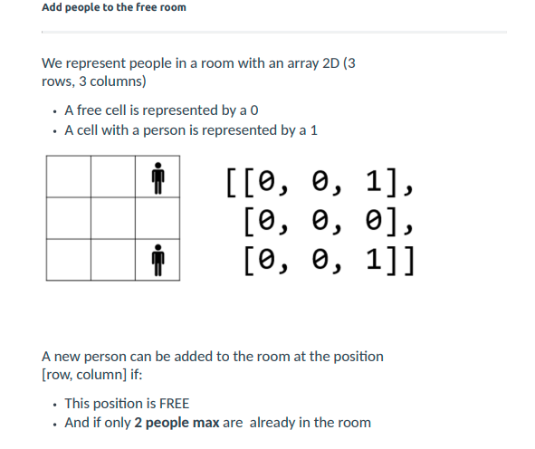

Example:

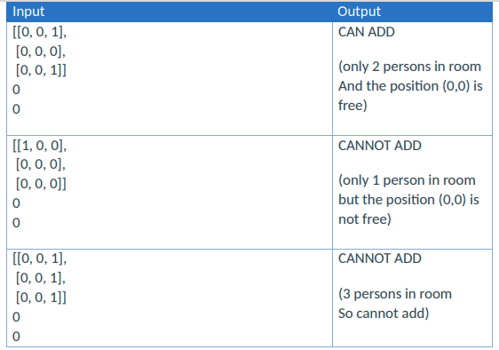

Q2 –look at this code:

personsInRoom = eval(input())      # it's an array 2D !

newPersonRow = int(input())        # row of the new person to add

newPersonColumn = int(input())     # column of the new person to add

def findPeople(array2D):

    peoplePosition = []

    for row in range(len(array2D)):

        for col in range(len(array2D[row])):

            if array2D[row][col] == 1 :

                peoplePosition.append([row,col])

    return peoplePosition

peopleInRoom = findPeople(personsInRoom);

if len(peopleInRoom) >=3:

    print("CANNOT ADD")

else:

    isCanAdd = True

    for value in peopleInRoom:

        if value[0] == newPersonRow and value[1] == newPersonColumn:

            isCanAdd = False

    if isCanAdd:

        print("CAN ADD")

    else:

        print("CANNOT ADD")

1. Why does this exercise need to create a function?

Answer: To check how many people in room.

2. what is the purpose of that function?

Answer: To know that how many people is in array.

1. why do we need to use a loop in loop in an array?

Answer: To check in row or in column whether has people or not.

1. what is the value of the variable peopleInRoom?

Answer: Value of this variable is array2D.

1. why we need to use if len(peopleInRoom) >=3: ?

Answer: To check how many people in room.

1. On else condition, why do we need to loop again?

Answer: To check which position has person.

1. why do we need the variable isCanAdd?

Answer: To check if the index of peopleInRoom equal newPersonRow and newPersonColumn it will return true.

**REVIEW OF EXERCICE 3**

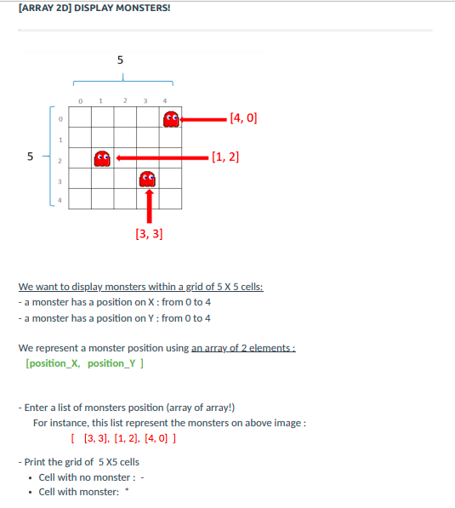

**0**

Result:

0 0 0 0 *

0 0 0 0 0

0 * 0 0 0

0 0 0 * 0

0 0 0 0 0

Q2 –look at this code:

def hasMonsterOnCell (monsterPosition, cellX, cellY):

    # Write your code here !

    for value in monsterPosition:

        if value[0] == cellY and value[1] ==cellX:

            return True

    return False

# MAIN CODE

values = eval(input())

# Write your code here !

result = ""

for row in range(5):

    for col in range(5):

        if hasMonsterOnCell(values,row,col):

            result+="*"

        else:

            result+="0"

    result +="\n"

print(result)

1. Why does this exercise need to create a function?

Answer: To check position which we input is equal position of grid or not.

2. what is the purpose of that function?

Answer: To check position which we input is equal position of grid or not.

3. What are the parameters in that function?

Answer: Parameters of this function has position of monster, row and column of monster.

4. Why do we need a loop of loop outside the function?

Answer: Loop outside the function to check the row and column of grid.

5. Why do we need to call function while we are looping?

Answer: To get Boolean true or false to add * or 0 into result.

6. Why do we add “\n” to the variable result?

Answer: Because we only 5 row and 5 columns. So when we get 5 rows and 5 column it will start new row.